**Copy Right Scan**

Github Repo: <https://github.ibm.com/modern-poc/java-k8s-cicd-test-cdt/tree/develop-s209>

Insight toolchain: <https://cloud.ibm.com/devops/insights/qualitydashboardNew?toolchainId=9c478366-cdf6-490d-9983-f9748c13a129>

CI toolchain: <https://cloud.ibm.com/devops/pipelines/5fd743f9-3dc4-440c-b3fc-838d6e3dbf96?env_id=ibm:yp:us-south>

Pipeline Image for Copycheck: **1.0**

**Source Code**

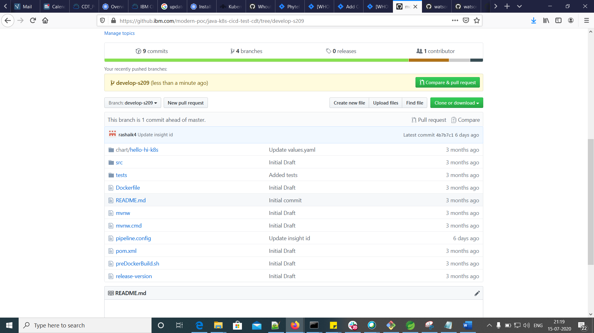

Pipeline.config

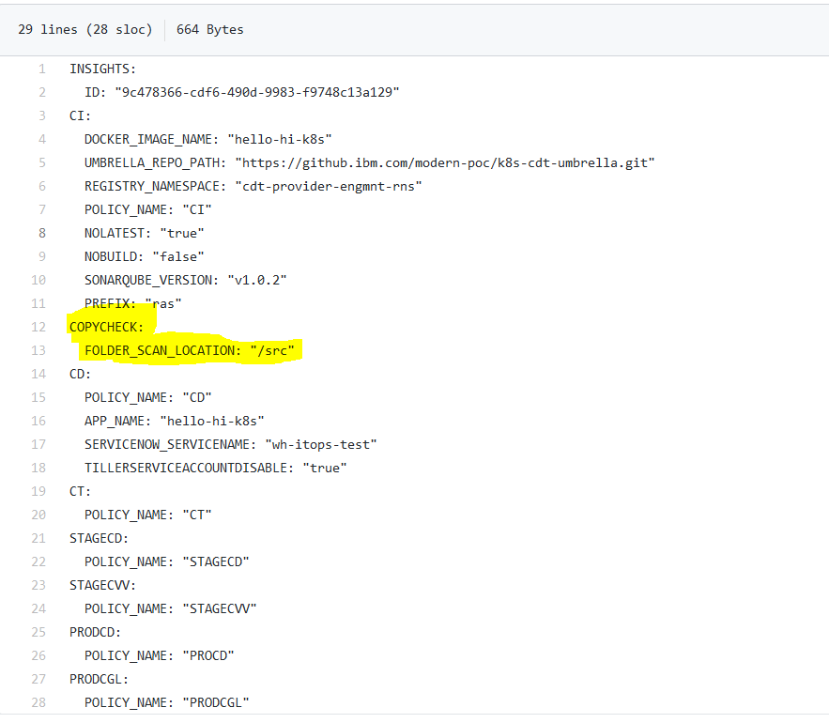

“Src” folder

“src” folder has 3 files only

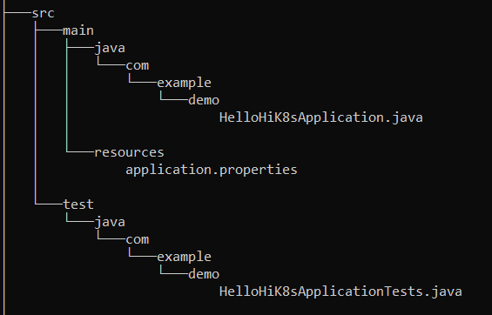

Case-1: There is no CopyRight statement added to these 3 files

CI log: <https://cloud.ibm.com/devops/pipelines/5fd743f9-3dc4-440c-b3fc-838d6e3dbf96/856e9b2e-d71c-4972-9e4d-f8fd0690d943/cf6880d6-e2fc-42e5-9a6d-9e5ce4d874a8?env_id=ibm:yp:us-south>

For this I got result like below



The Insight dashboard look like below

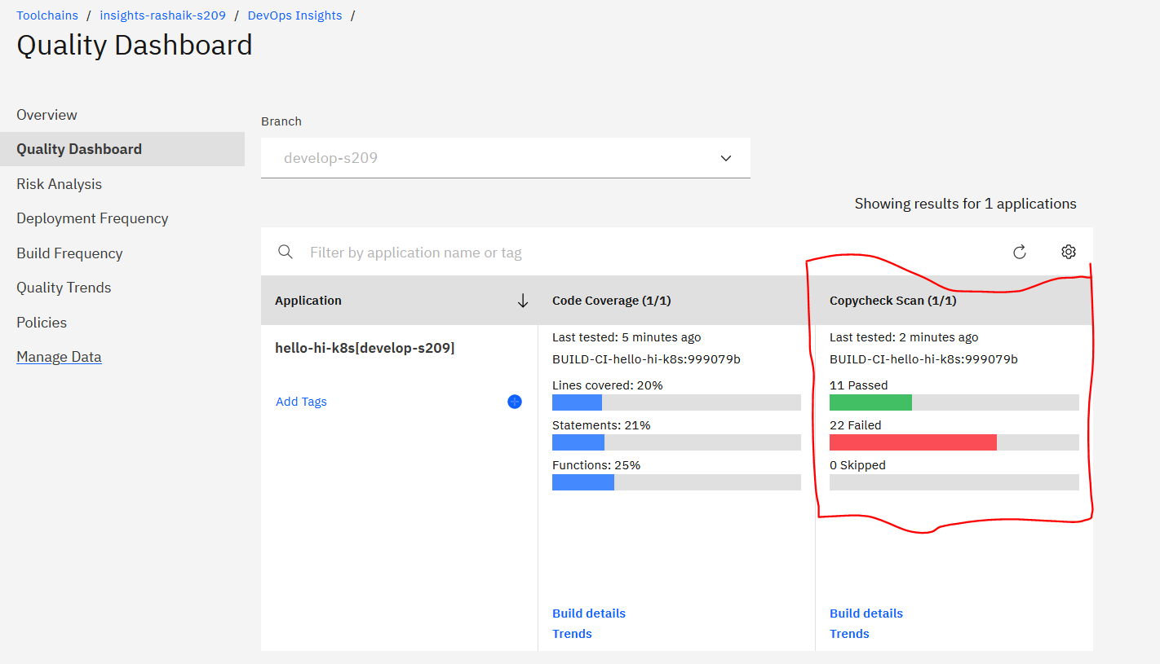

Below are the copyright scenarios (rules) considered for this case-1 –

* test_copyright_IBM_present_in - 3
* test_copyright_basic_exists_in - 3
* test_copyright_confidential_valid_in - 3
* test_copyright_licensed_valid_in - 3
* test_copyright_oco_valid_in - 2 (no properties file)
* test_copyright_trade_valid_in - 2 (no properties file)
* test_copyright_usgovt_valid_in - 3
* test_copyright_year_valid_in – 3

Total 22 failure cases, but need to figure out what are the remaining 11 cases as well.

Case – 2: Add below Copyright statement to these 3 files

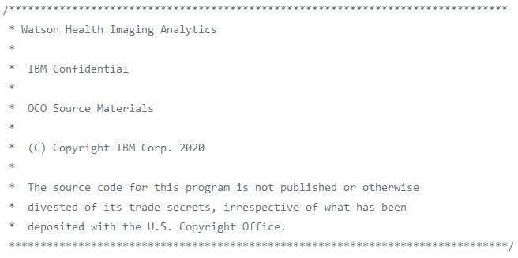

Source code

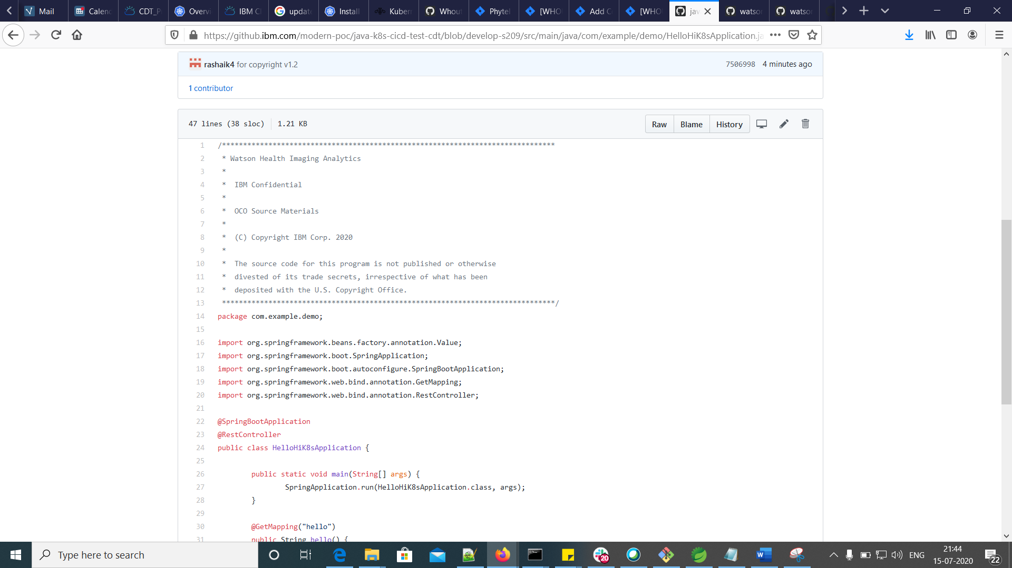

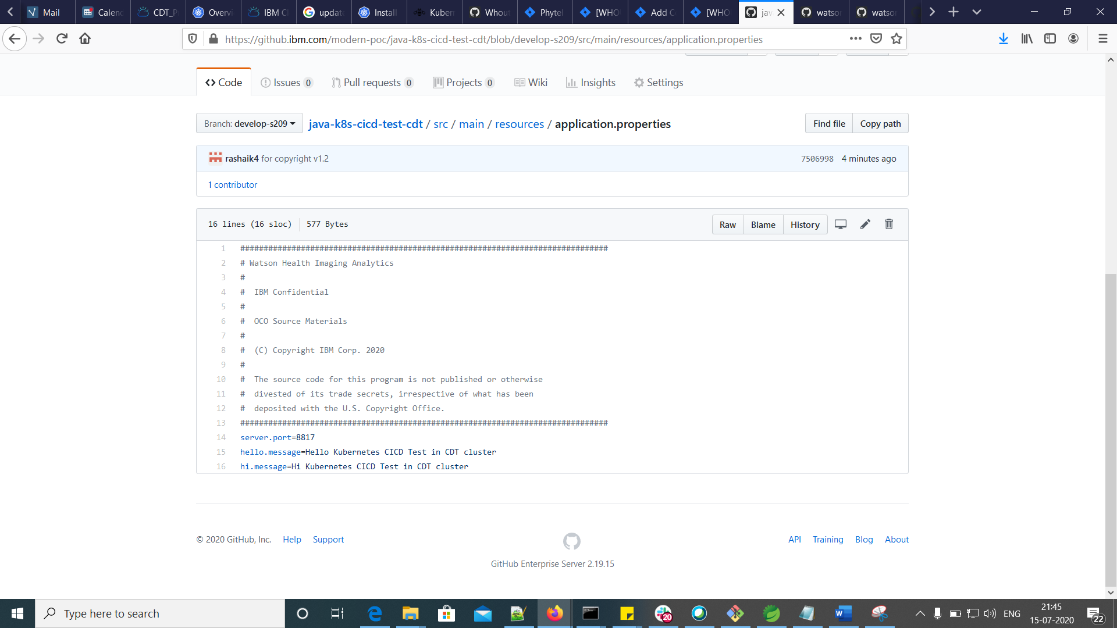

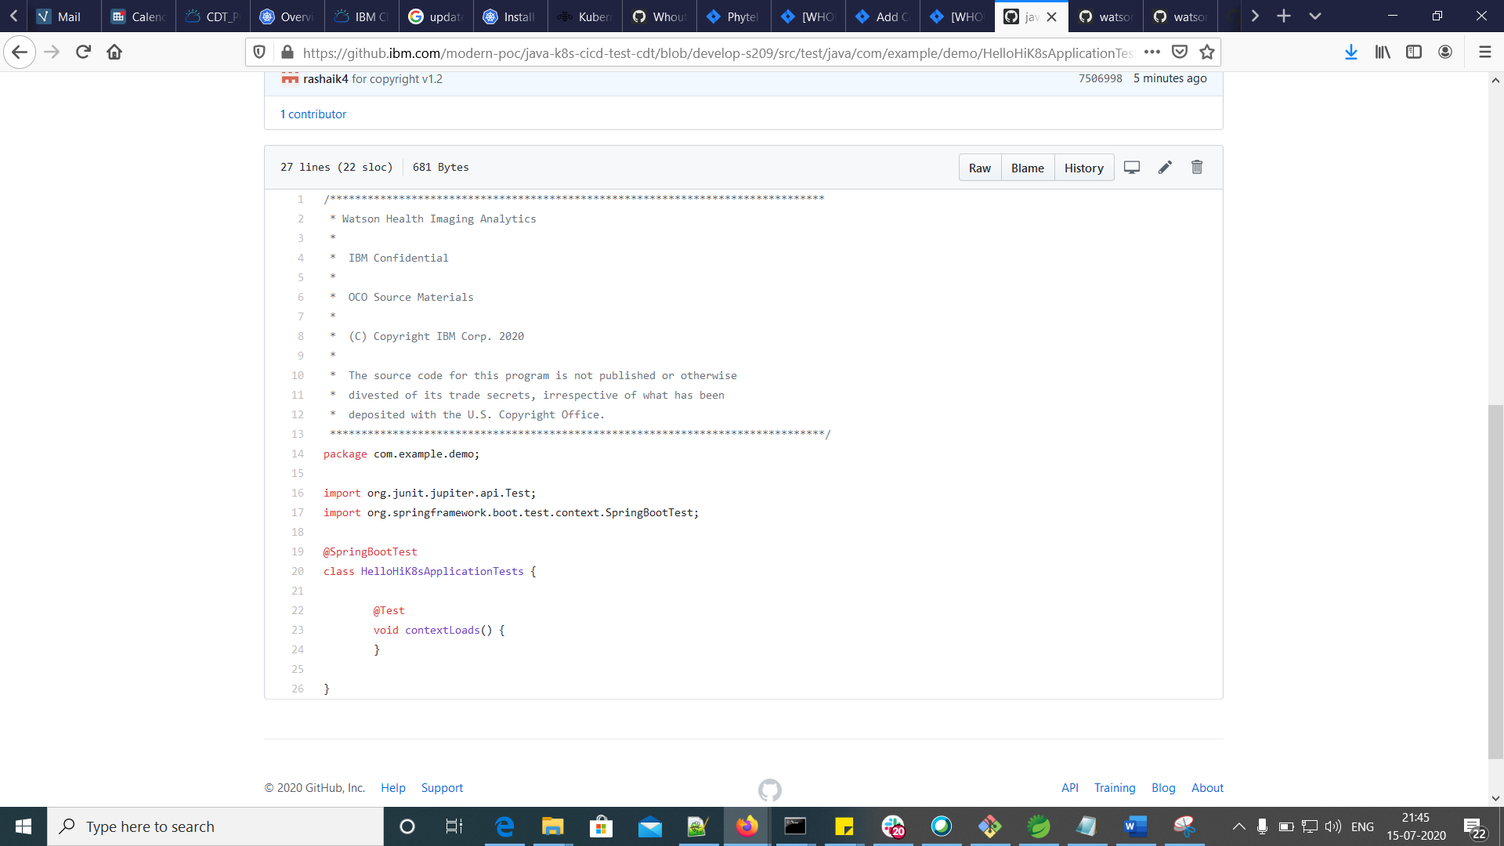

CI log: <https://cloud.ibm.com/devops/pipelines/5fd743f9-3dc4-440c-b3fc-838d6e3dbf96/856e9b2e-d71c-4972-9e4d-f8fd0690d943/cf6880d6-e2fc-42e5-9a6d-9e5ce4d874a8?env_id=ibm:yp:us-south>

For this I got result like below



The Insight dashboard look like below

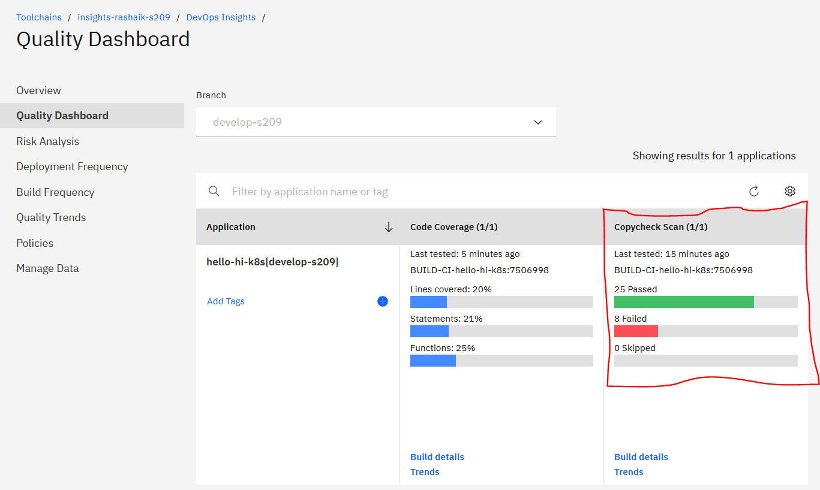

Below are the copyright scenarios (rules) considered for this case-2 –

* test_copyright_licensed_valid_in - 3
* test_copyright_oco_valid_in - 1 (in properties)
* test_copyright_trade_valid_in - 1 (in properties)
* test_copyright_usgovt_valid_in – 3

Total 8 failure cases. Need to get the correct copyright statement.

I am confused with the “oco & trade” rule behaviour on properties file.

Need to have a copyright statement which doesn’t provide any copy right issue.

Case – 3: Add below AUTOFIX statement to pipeline config

COPYCHECK:

AUTOFIX: "true"

Source Code

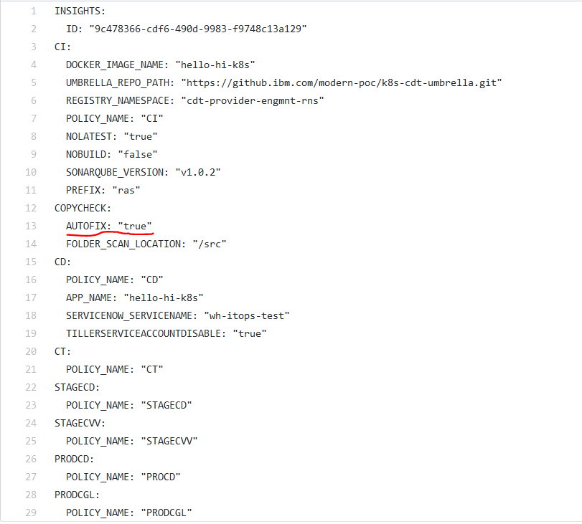

CI log: <https://cloud.ibm.com/devops/pipelines/5fd743f9-3dc4-440c-b3fc-838d6e3dbf96/856e9b2e-d71c-4972-9e4d-f8fd0690d943/cf6880d6-e2fc-42e5-9a6d-9e5ce4d874a8/c95bc7d7-046b-4266-a34e-de5535672158/ea823e4e-2526-4e68-a7a7-c9f7120d4a2a?env_id=ibm:yp:us-south>

For this I got the job failed with below error. This generated at the time of creating PR to my git repo

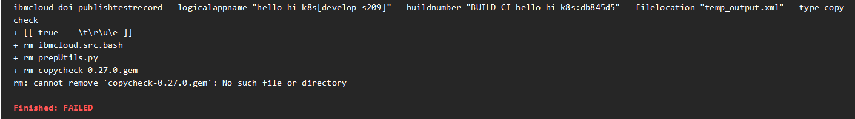

The failure related code is at line: 215 in run.sh in github: <https://github.ibm.com/watson-health-development/wh-ta-copycheck/blob/stable-102/run.sh>

The insights dashboard looks like below

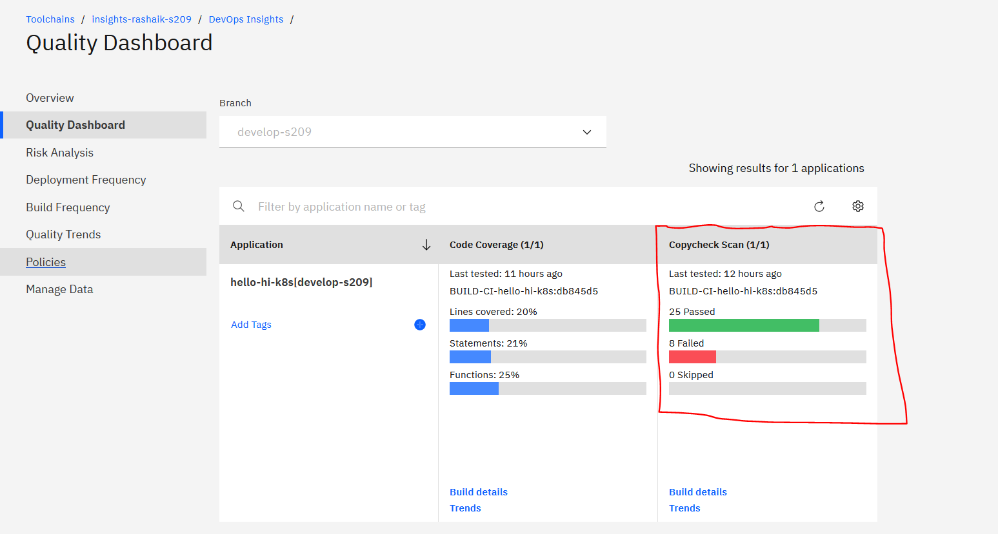

Case – 4: Add below Copyright statement to these 3 files

**Note:** Copyright statements in Java files and properties files are **different**

**Source Code**

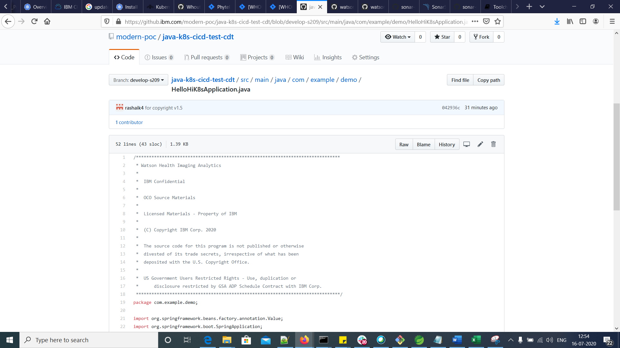

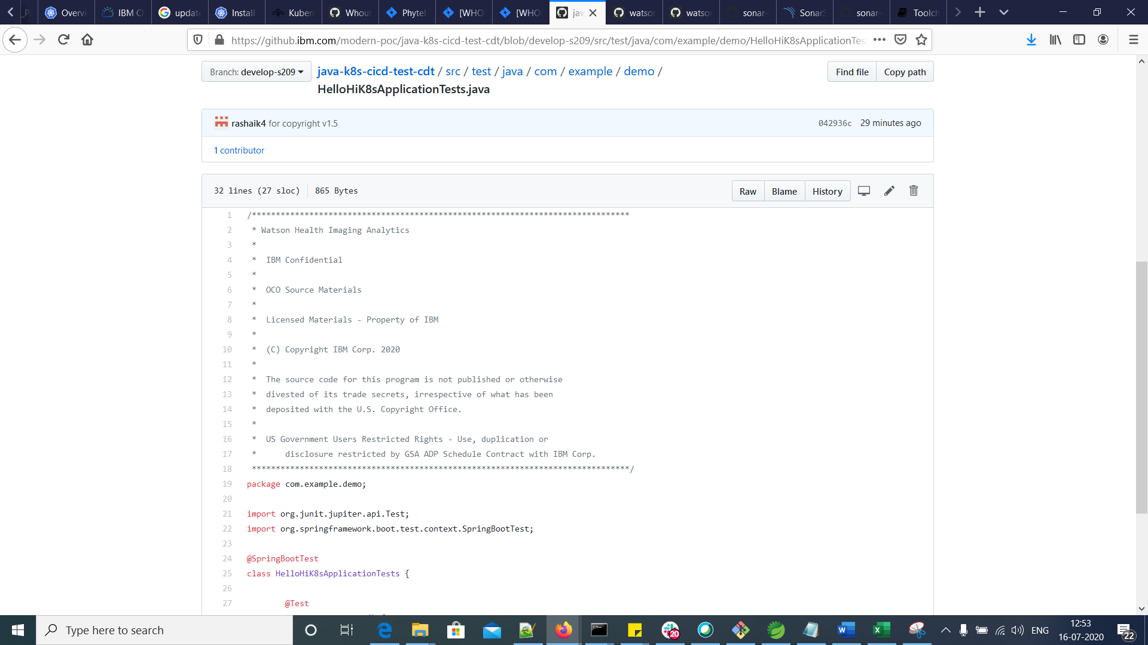

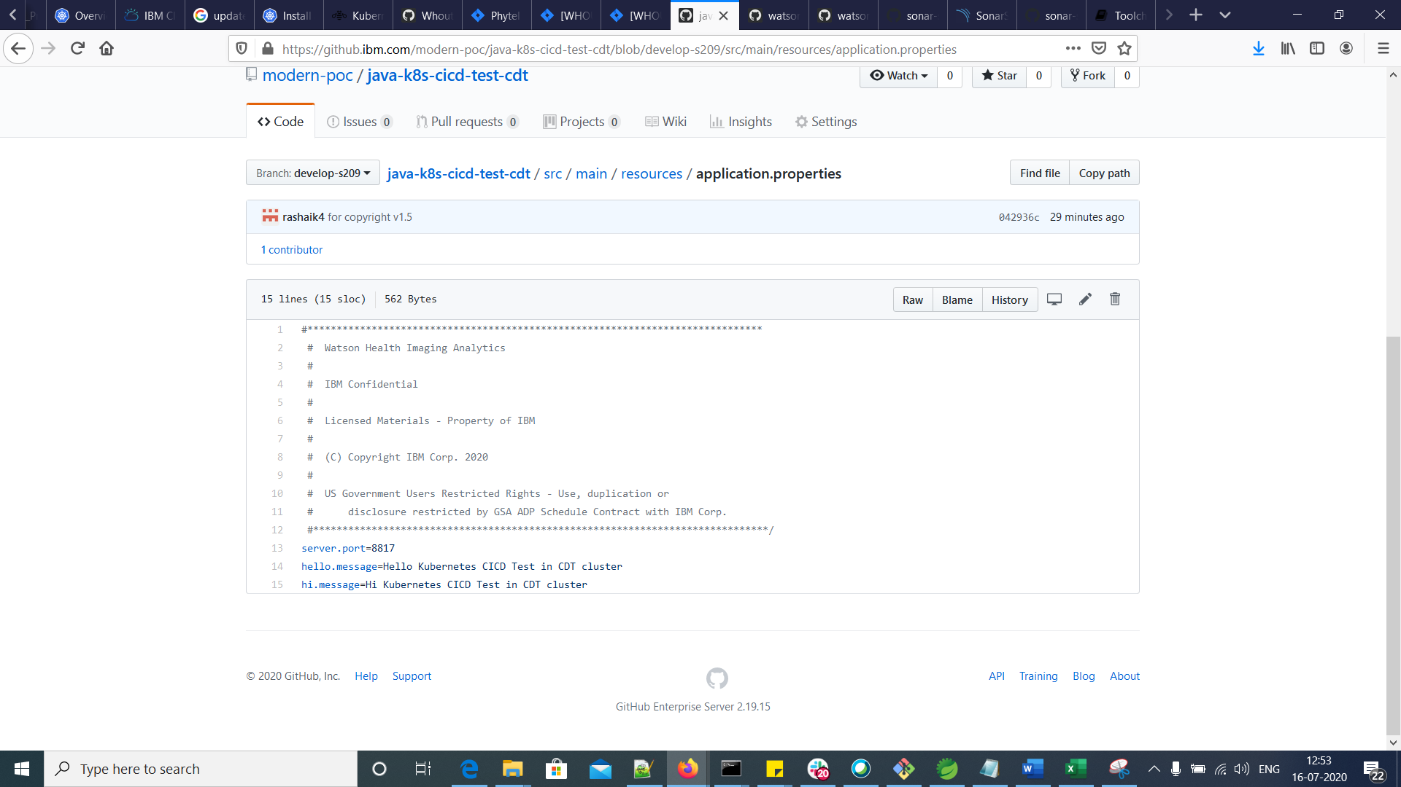

CI log: <https://cloud.ibm.com/devops/pipelines/5fd743f9-3dc4-440c-b3fc-838d6e3dbf96/856e9b2e-d71c-4972-9e4d-f8fd0690d943/cf6880d6-e2fc-42e5-9a6d-9e5ce4d874a8/067e99c4-73b7-4b16-8a42-4aeedfccf988/08a0632a-7f03-4e49-a134-048d0efc4df5?env_id=ibm:yp:us-south>

For this I got result like below



The Insight dashboard look like below

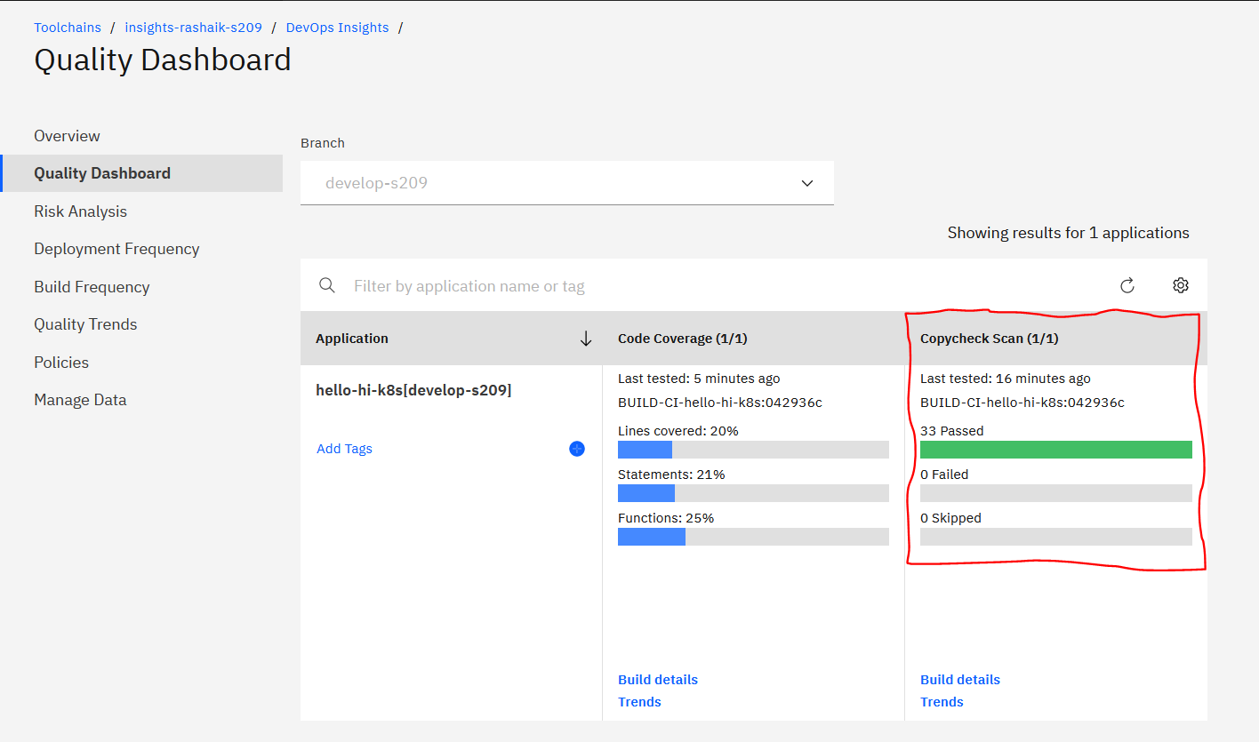

**Below are my findings or mappings used for Case-4 to get 0 failures.**

|  |  |  |  |
| --- | --- | --- | --- |
| **Option** | **Rule** | **Required text** | **Default Value** |
| internal_program | test_copyright_IBM_present | IBM Confidential | TRUE |
|  | test_copyright_basic_exists | Watson Health Imaging Analytics |  |
|  | test_copyright_confidential_valid | (C) **Copyright IBM Corp.** 2020 |  |
|  | test_copyright_licensed_valid | Licensed Materials - Property of IBM |  |
| Object Code Only | test_copyright_oco_valid | OCO Source Materials |  |
|  | test_copyright_trade_valid | The source code for this program is not published or otherwise divested of its **trade** secrets, irrespective of what has been deposited with the U.S. Copyright Office. |  |
| us_dist_only | test_copyright_usgovt_valid | **US Government** Users Restricted Rights - Use, duplication or disclosure restricted by GSA ADP Schedule Contract with IBM Corp. | TRUE |
|  | test_copyright_year_valid | (C) Copyright IBM Corp. **2020** |  |
| Microcode |  | Microcode Source Materials |  |
| restricted_materials |  | Restricted Materials of IBM | FALSE |
| Licensed Internal |  | Licensed Internal Code Source Materials |  |
|  |  |  |  |
|  | Assumption from the sample copyright that I have | |  |
|  | is the mapping between option and Rule correct? | |  |

**Reference:**

<https://github.ibm.com/watson-health-development/wh-ta-copycheck>

<https://github.ibm.com/watson-health-development/wh-ta-example-copycheck/blob/master/.copycheck_conf>

<https://github.ibm.com/tron/copycheck-gem#usage--options--flags>

<https://pages.github.ibm.com/the-playbook/developer-guide/legal-guidance/index.html>

<https://github.ibm.com/watson-health-development/wh-ta-copycheck#start-up--installation>

<https://github.ibm.com/watson-health-development/wh-ta-copycheck/blob/stable-102/run.sh>